Hursh Desai

**Managerial Problem Definition**

Decisions to be made – Which cities should be allocated to which of the 10 districts

Objective – Maximize republican-dominated districts

Restrictions – District populations must be between 150k and 350k. Each city can only be assigned to one district.

*Nonlinear Binary*

**Model Formulation**

Decision Variables:

Xij, for i for each city from 1 to 18, and j for each district from 1 to 10

Objective Function:

Maximize: =IF(SUMPRODUCT(Republican #s , Xij)>SUMPRODUCT(Democrat #s , Xij),1,0)

Constraints:

Total # of voters in each district > 150 and < 350

Xi = 1 (each city can only be used once)

**Solution Methodology**

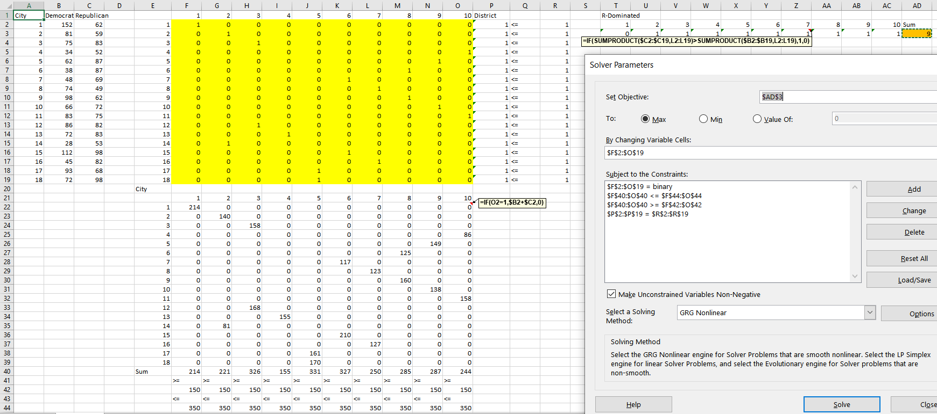

*Nonlinear with 18DVs*

**Model Formulation**

Decision Variables:

Xi from 1 to 18 where each represents the district chosen for that particular city

Intermediate Variables

RIj Republicans in each district

DIi Democrats in reach district

1000 if M1 is less than 150,000

1000 if M2 is greater than 350,000

Objective Function:

Maximize:SUM(Xi – (M1 + M2))

Constraints:

Total dem and rep in each district > 150 and < 350

Xi = 1 (each city can only be used once)

M1 and M2 for big M

Xi >= 1

Xi <= 10

**Solution Methodology**

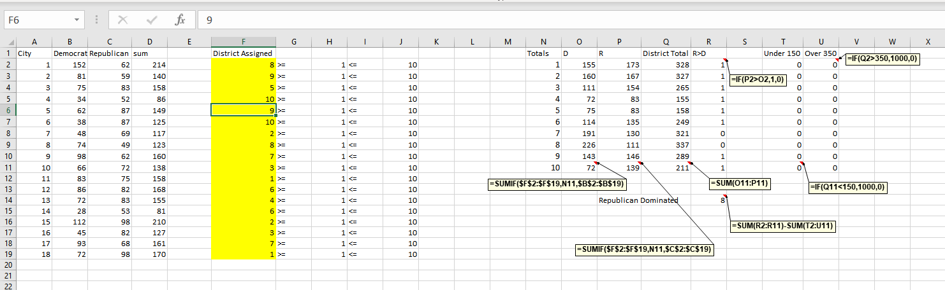

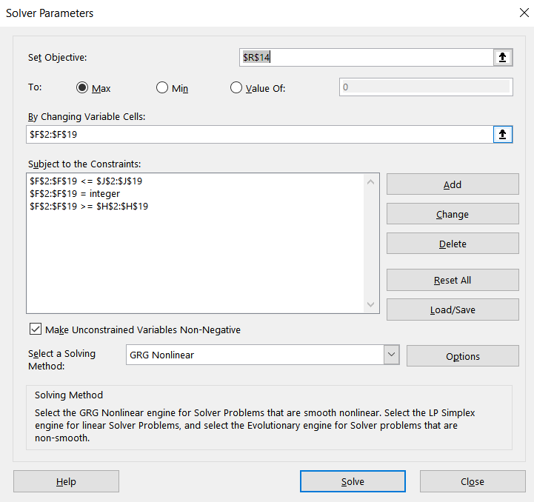

*Linear with Binary variables*

**Model Formulation**

Decision Variables:

Xij, binary where i is each city from 1 to 18, and j is each district from 1 to 10

Yi, binary where each is if district is republican dominated

Objective Function:

Maximize: SUM(Yi)

Constraints:

Total dem and rep in each district > 150 and < 350

Xi = 1 (each city can only be used once)

D - R < M1*(1- Yi)      
R - D < M2* Yi

D - R <= M1*(1- Yi) - 1  
R - D <= M2* Yi - 1

M1 and M2 for big M

**Solution Methodology**

